Team A-Work

Analytical Modeling

Questions

|  |  |  |  |  |  |
| --- | --- | --- | --- | --- | --- |
| Question | Reference in Document | Question by | Question Date | Resolution | Resolved  Date |
| Orign-up-missing,channel-sales-MISSING in these 2 variables do we need to comment on these fields or adjust for missing values? I do not know what these columns are telling us. | Read only 001 End to End Churn- 2.1 Exploratory Analysis section | EW | 7-9-25 | The “MISSING” are legitimate classes from the data. | 7-10-25 |
| MISSING Category in Sales by Channel | “” | “” | “” | The “MISSING” are legitimate classes from the data. | 7-10-25 |
| If I have to explain in the presentation I need to know why advanced boosting requires Xgboost and one-hot encode | Under 3 oo1 end to end churn | “” | “” | ML processes only work with numbers. When dealing with string-based categories (or classes) versus integers, you turn the classes into their own features through one-hot-encoding, which creates new feature columns for every possible class value, and then assigns a 0 or a 1 value to the new feature column, depending on whether or not that record was a member of that class |  |
| In our analysis, what does $50–$200+ per customer per month mean, and what does that equate to overall pricing adjustment? | Under #15 Key Takeaways  Business Impact | MR | 7-10-25 | Take a look at the latest version. There isn’t a lot of price sensitivity for non-churning customers. The new workflow does show the optimal rate increase that results in minimal churn, but maximizing for revenue. In most classes, we can increase price significantly, increase churn in that class by a couple of points, but net substantially more total revenue |  |
| On Churn Risk Distribution, is there any noticeable consistency that appears in the risk distribution where we can target those specific higher risk customers, that can help keep those customers and help our bottom line? | 14 Final Summary of Model Development and Analysis | MR | 7-10-25 | Good question. From the lastest report, search for the heading title, but here are highlights on customer that did churn that might not have churned with a discount. For current customers, discounts really don’t seem to make much of a difference as the are not currently at risk.:  6. EXECUTIVE SUMMARY - HIGH-RISK CUSTOMERS ANALYSIS ============================================================ 🎯 OVERALL IMPACT OF 20% BLANKET DISCOUNT (PREVENTIVE):  Total high-risk customers analyzed: 109  Potential saves (below 50% risk): 0 (0.0%)  Potential saves (below 30% risk): 8 (7.3%)  Potential saves (below 20% risk): 14 (12.8%)  Average risk reduction: 0.5 percentage points  📊 BEST PERFORMING CHANNELS FOR RETENTION:  Highest save rate (50% threshold): foosdfpfkusacimwkcsosbicdxkicaua (0.0%)  Highest save rate (30% threshold): foosdfpfkusacimwkcsosbicdxkicaua (7.9%)  💰 BUSINESS IMPLICATIONS:  • 0 high-risk customers can be moved to safer risk levels  • 8 customers at 30% threshold - moderate intervention success  • Early intervention at 20% risk shows 14 preventable churns  • Proactive retention campaigns show significant potential impact  📋 STRATEGIC RECOMMENDATIONS:  • Implement early warning systems for customers reaching 20% churn risk  • Develop channel-specific retention offers based on effectiveness rates  • Create tiered discount strategies: 10% at 20% risk, 15% at 30% risk, 20% at 50% risk  • Focus retention budget on channels with highest save rates  • Establish continuous risk monitoring with automated intervention triggers  💵 ESTIMATED BUSINESS VALUE (ANNUAL):  • Value of customers potentially saved (50% threshold): $0  • Value of customers potentially saved (30% threshold): $12,000  • Cost of 20% discount program: ~$39,240 annually  • Net ROI (50% threshold): $-39,240 |  |
|  |  |  |  |  |  |

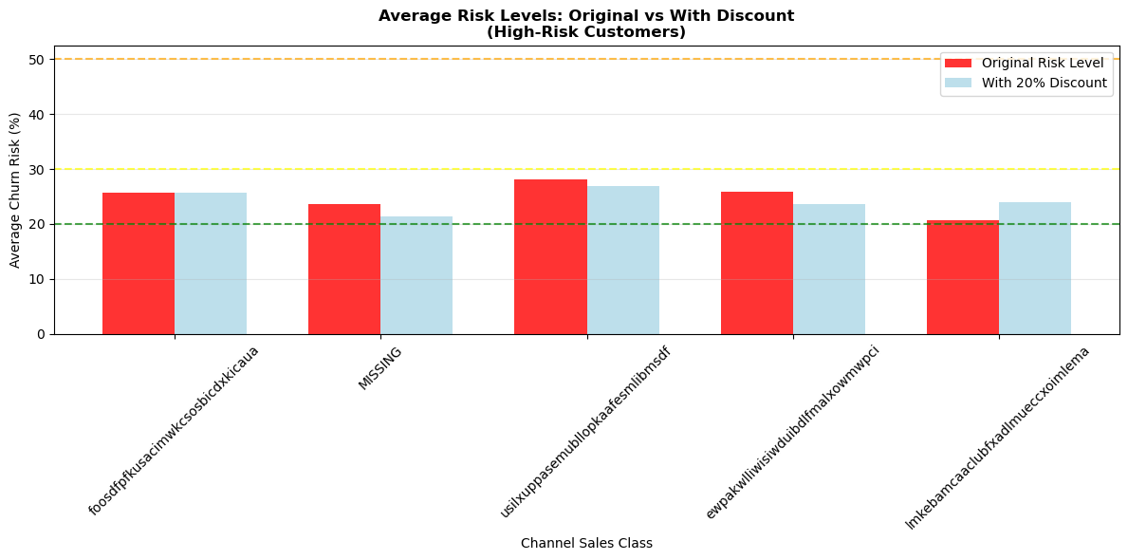

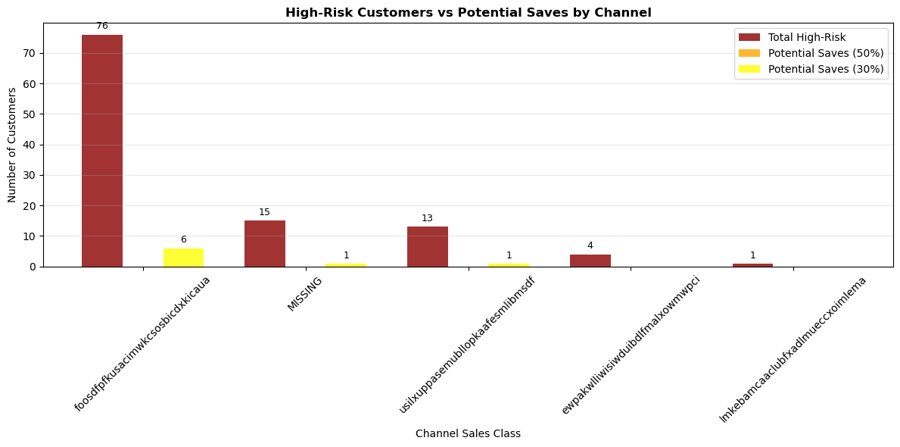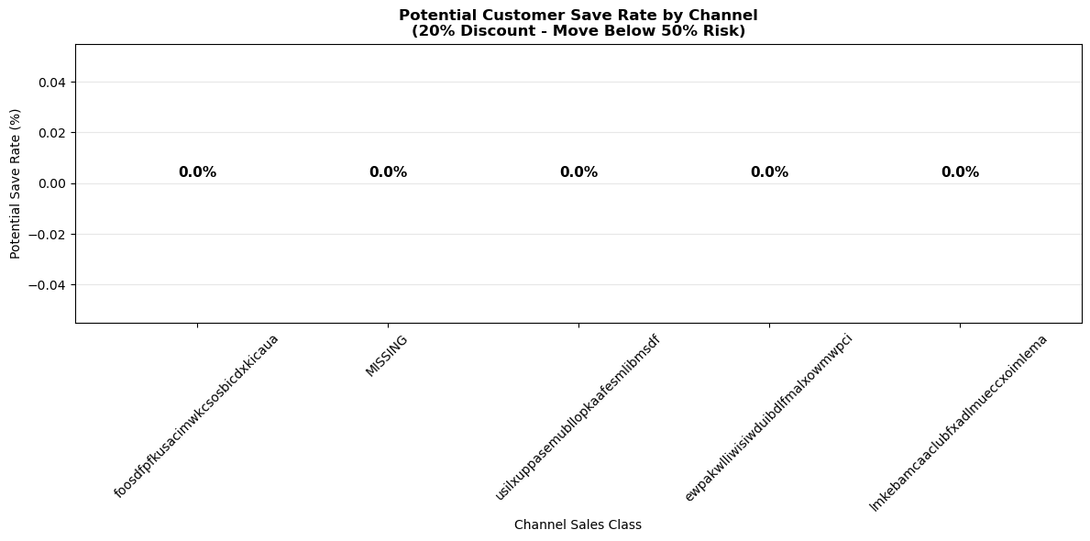

I thought this was interesting: For our current channel sales non-churned customers, these are the optimal prices that minimize churn while maximizing revenue. So more people churn when we raise the price, but we make more $$$$$  
  
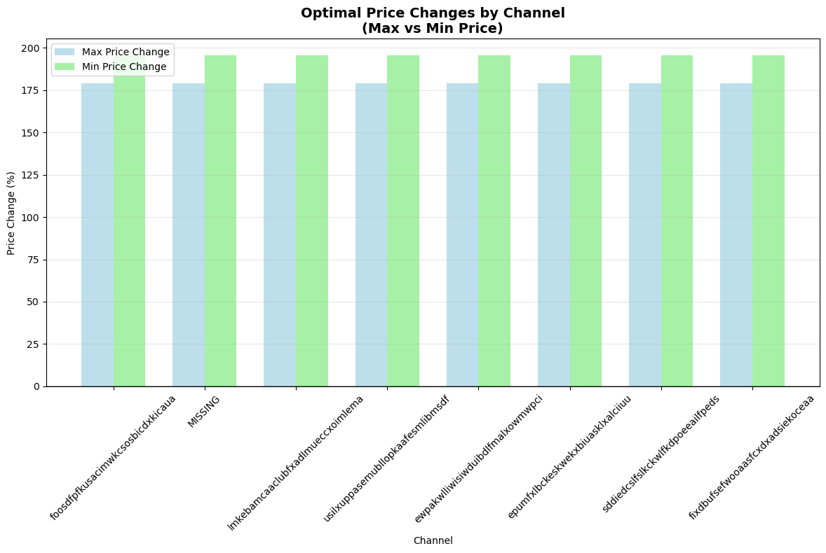

5. CORRECTED PRICING OPTIMIZATION RESULTS  
--------------------------------------------------  
  
📋 FOOSDFPFKUSACIMWKCSOSBICDXKICAUA CHANNEL - CORRECTED ANALYSIS:

|  |  |  |  |  |  |  |  |  |  |
| --- | --- | --- | --- | --- | --- | --- | --- | --- | --- |
|  | **Max_Price** | **Min_Price** | **Max_Price_Change_%** | **Min_Price_Change_%** | **New_Churn** | **Churn_Change** | **New_Revenue** | **Revenue_Change_%** | **Net_Margin** |
| **35** | 0.158 | 0.147 | 179.053 | 195.662 | 0.162 | 0.062 | 431.036 | 187.358 | 349.828 |
| **34** | 0.158 | 0.126 | 179.053 | 153.424 | 0.160 | 0.060 | 399.358 | 166.239 | 319.132 |
| **33** | 0.158 | 0.105 | 179.053 | 111.187 | 0.147 | 0.047 | 367.680 | 145.120 | 294.250 |
| **27** | 0.136 | 0.126 | 139.189 | 153.424 | 0.153 | 0.053 | 369.460 | 146.307 | 293.193 |
| **26** | 0.136 | 0.105 | 139.189 | 111.187 | 0.139 | 0.039 | 337.782 | 125.188 | 268.187 |
| **32** | 0.158 | 0.084 | 179.053 | 68.950 | 0.137 | 0.037 | 336.002 | 124.002 | 267.427 |
| **20** | 0.113 | 0.105 | 99.324 | 111.187 | 0.132 | 0.032 | 307.883 | 105.255 | 241.860 |
| **25** | 0.136 | 0.084 | 139.189 | 68.950 | 0.130 | 0.030 | 306.104 | 104.069 | 241.235 |
| **31** | 0.158 | 0.063 | 179.053 | 26.712 | 0.135 | 0.035 | 304.324 | 102.883 | 236.979 |
| **19** | 0.113 | 0.084 | 99.324 | 68.950 | 0.121 | 0.021 | 276.205 | 84.137 | 215.830 |

🎯 OPTIMAL PRICING FOR FOOSDFPFKUSACIMWKCSOSBICDXKICAUA:  
 Max Price: $0.1584 (+179.1%)  
 Min Price: $0.1467 (+195.7%)  
 Churn: 10.0% → 16.2% (+6.2%)  
 Revenue: $150.00 → $431.04 (+187.4%)  
 Net Margin: $349.83  
  
📋 MISSING CHANNEL - CORRECTED ANALYSIS:

|  |  |  |  |  |  |  |  |  |  |
| --- | --- | --- | --- | --- | --- | --- | --- | --- | --- |
|  | **Max_Price** | **Min_Price** | **Max_Price_Change_%** | **Min_Price_Change_%** | **New_Churn** | **Churn_Change** | **New_Revenue** | **Revenue_Change_%** | **Net_Margin** |
| **35** | 0.158 | 0.147 | 179.053 | 195.662 | 0.108 | 0.045 | 431.036 | 187.358 | 377.035 |
| **34** | 0.158 | 0.126 | 179.053 | 153.424 | 0.108 | 0.044 | 399.358 | 166.239 | 345.582 |
| **27** | 0.136 | 0.126 | 139.189 | 153.424 | 0.104 | 0.041 | 369.460 | 146.307 | 317.453 |
| **33** | 0.158 | 0.105 | 179.053 | 111.187 | 0.101 | 0.038 | 367.680 | 145.120 | 317.080 |
| **32** | 0.158 | 0.084 | 179.053 | 68.950 | 0.091 | 0.027 | 336.002 | 124.002 | 290.604 |
| **26** | 0.136 | 0.105 | 139.189 | 111.187 | 0.097 | 0.033 | 337.782 | 125.188 | 289.497 |
| **20** | 0.113 | 0.105 | 99.324 | 111.187 | 0.090 | 0.027 | 307.883 | 105.255 | 262.926 |
| **25** | 0.136 | 0.084 | 139.189 | 68.950 | 0.086 | 0.023 | 306.104 | 104.069 | 262.865 |
| **31** | 0.158 | 0.063 | 179.053 | 26.712 | 0.092 | 0.029 | 304.324 | 102.883 | 258.181 |
| **19** | 0.113 | 0.084 | 99.324 | 68.950 | 0.079 | 0.015 | 276.205 | 84.137 | 236.837 |

🎯 OPTIMAL PRICING FOR MISSING:  
 Max Price: $0.1584 (+179.1%)  
 Min Price: $0.1467 (+195.7%)  
 Churn: 6.3% → 10.8% (+4.5%)  
 Revenue: $150.00 → $431.04 (+187.4%)  
 Net Margin: $377.03  
  
📋 LMKEBAMCAACLUBFXADLMUECCXOIMLEMA CHANNEL - CORRECTED ANALYSIS:

|  |  |  |  |  |  |  |  |  |  |
| --- | --- | --- | --- | --- | --- | --- | --- | --- | --- |
|  | **Max_Price** | **Min_Price** | **Max_Price_Change_%** | **Min_Price_Change_%** | **New_Churn** | **Churn_Change** | **New_Revenue** | **Revenue_Change_%** | **Net_Margin** |
| **35** | 0.158 | 0.147 | 179.053 | 195.662 | 0.094 | 0.043 | 431.036 | 187.358 | 384.083 |
| **34** | 0.158 | 0.126 | 179.053 | 153.424 | 0.094 | 0.043 | 399.358 | 166.239 | 352.343 |
| **27** | 0.136 | 0.126 | 139.189 | 153.424 | 0.086 | 0.035 | 369.460 | 146.307 | 326.523 |
| **33** | 0.158 | 0.105 | 179.053 | 111.187 | 0.084 | 0.034 | 367.680 | 145.120 | 325.430 |
| **26** | 0.136 | 0.105 | 139.189 | 111.187 | 0.077 | 0.026 | 337.782 | 125.188 | 299.475 |
| **32** | 0.158 | 0.084 | 179.053 | 68.950 | 0.077 | 0.026 | 336.002 | 124.002 | 297.581 |
| **20** | 0.113 | 0.105 | 99.324 | 111.187 | 0.072 | 0.021 | 307.883 | 105.255 | 272.000 |
| **25** | 0.136 | 0.084 | 139.189 | 68.950 | 0.068 | 0.017 | 306.104 | 104.069 | 271.972 |
| **31** | 0.158 | 0.063 | 179.053 | 26.712 | 0.079 | 0.028 | 304.324 | 102.883 | 264.773 |
| **19** | 0.113 | 0.084 | 99.324 | 68.950 | 0.063 | 0.012 | 276.205 | 84.137 | 244.737 |

🎯 OPTIMAL PRICING FOR LMKEBAMCAACLUBFXADLMUECCXOIMLEMA:  
 Max Price: $0.1584 (+179.1%)  
 Min Price: $0.1467 (+195.7%)  
 Churn: 5.1% → 9.4% (+4.3%)  
 Revenue: $150.00 → $431.04 (+187.4%)  
 Net Margin: $384.08  
  
📋 USILXUPPASEMUBLLOPKAAFESMLIBMSDF CHANNEL - CORRECTED ANALYSIS:

|  |  |  |  |  |  |  |  |  |  |
| --- | --- | --- | --- | --- | --- | --- | --- | --- | --- |
|  | **Max_Price** | **Min_Price** | **Max_Price_Change_%** | **Min_Price_Change_%** | **New_Churn** | **Churn_Change** | **New_Revenue** | **Revenue_Change_%** | **Net_Margin** |
| **35** | 0.158 | 0.147 | 179.053 | 195.662 | 0.157 | 0.065 | 431.036 | 187.358 | 352.730 |
| **34** | 0.158 | 0.126 | 179.053 | 153.424 | 0.156 | 0.064 | 399.358 | 166.239 | 321.478 |
| **27** | 0.136 | 0.126 | 139.189 | 153.424 | 0.141 | 0.050 | 369.460 | 146.307 | 298.736 |
| **33** | 0.158 | 0.105 | 179.053 | 111.187 | 0.145 | 0.053 | 367.680 | 145.120 | 295.325 |
| **32** | 0.158 | 0.084 | 179.053 | 68.950 | 0.126 | 0.034 | 336.002 | 124.002 | 272.859 |
| **26** | 0.136 | 0.105 | 139.189 | 111.187 | 0.130 | 0.039 | 337.782 | 125.188 | 272.592 |
| **25** | 0.136 | 0.084 | 139.189 | 68.950 | 0.113 | 0.021 | 306.104 | 104.069 | 249.719 |
| **20** | 0.113 | 0.105 | 99.324 | 111.187 | 0.125 | 0.034 | 307.883 | 105.255 | 245.208 |
| **31** | 0.158 | 0.063 | 179.053 | 26.712 | 0.125 | 0.033 | 304.324 | 102.883 | 241.786 |
| **19** | 0.113 | 0.084 | 99.324 | 68.950 | 0.108 | 0.016 | 276.205 | 84.137 | 222.362 |

🎯 OPTIMAL PRICING FOR USILXUPPASEMUBLLOPKAAFESMLIBMSDF:  
 Max Price: $0.1584 (+179.1%)  
 Min Price: $0.1467 (+195.7%)  
 Churn: 9.2% → 15.7% (+6.5%)  
 Revenue: $150.00 → $431.04 (+187.4%)  
 Net Margin: $352.73  
  
📋 EWPAKWLLIWISIWDUIBDLFMALXOWMWPCI CHANNEL - CORRECTED ANALYSIS:

|  |  |  |  |  |  |  |  |  |  |
| --- | --- | --- | --- | --- | --- | --- | --- | --- | --- |
|  | **Max_Price** | **Min_Price** | **Max_Price_Change_%** | **Min_Price_Change_%** | **New_Churn** | **Churn_Change** | **New_Revenue** | **Revenue_Change_%** | **Net_Margin** |
| **35** | 0.158 | 0.147 | 179.053 | 195.662 | 0.118 | 0.047 | 431.036 | 187.358 | 371.792 |
| **34** | 0.158 | 0.126 | 179.053 | 153.424 | 0.119 | 0.047 | 399.358 | 166.239 | 339.984 |
| **27** | 0.136 | 0.126 | 139.189 | 153.424 | 0.109 | 0.037 | 369.460 | 146.307 | 315.036 |
| **33** | 0.158 | 0.105 | 179.053 | 111.187 | 0.110 | 0.039 | 367.680 | 145.120 | 312.572 |
| **26** | 0.136 | 0.105 | 139.189 | 111.187 | 0.100 | 0.029 | 337.782 | 125.188 | 287.603 |
| **32** | 0.158 | 0.084 | 179.053 | 68.950 | 0.101 | 0.030 | 336.002 | 124.002 | 285.269 |
| **20** | 0.113 | 0.105 | 99.324 | 111.187 | 0.092 | 0.021 | 307.883 | 105.255 | 261.776 |
| **25** | 0.136 | 0.084 | 139.189 | 68.950 | 0.093 | 0.021 | 306.104 | 104.069 | 259.810 |
| **31** | 0.158 | 0.063 | 179.053 | 26.712 | 0.102 | 0.030 | 304.324 | 102.883 | 253.482 |
| **19** | 0.113 | 0.084 | 99.324 | 68.950 | 0.083 | 0.012 | 276.205 | 84.137 | 234.548 |

🎯 OPTIMAL PRICING FOR EWPAKWLLIWISIWDUIBDLFMALXOWMWPCI:  
 Max Price: $0.1584 (+179.1%)  
 Min Price: $0.1467 (+195.7%)  
 Churn: 7.2% → 11.8% (+4.7%)  
 Revenue: $150.00 → $431.04 (+187.4%)  
 Net Margin: $371.79  
  
📋 EPUMFXLBCKESKWEKXBIUASKLXALCIIUU CHANNEL - CORRECTED ANALYSIS:

|  |  |  |  |  |  |  |  |  |  |
| --- | --- | --- | --- | --- | --- | --- | --- | --- | --- |
|  | **Max_Price** | **Min_Price** | **Max_Price_Change_%** | **Min_Price_Change_%** | **New_Churn** | **Churn_Change** | **New_Revenue** | **Revenue_Change_%** | **Net_Margin** |
| **35** | 0.158 | 0.147 | 179.053 | 195.662 | 0.128 | 0.088 | 431.036 | 187.358 | 367.148 |
| **34** | 0.158 | 0.126 | 179.053 | 153.424 | 0.130 | 0.090 | 399.358 | 166.239 | 334.358 |
| **33** | 0.158 | 0.105 | 179.053 | 111.187 | 0.113 | 0.073 | 367.680 | 145.120 | 311.014 |
| **27** | 0.136 | 0.126 | 139.189 | 153.424 | 0.124 | 0.084 | 369.460 | 146.307 | 307.238 |
| **32** | 0.158 | 0.084 | 179.053 | 68.950 | 0.098 | 0.058 | 336.002 | 124.002 | 287.113 |
| **26** | 0.136 | 0.105 | 139.189 | 111.187 | 0.108 | 0.068 | 337.782 | 125.188 | 283.893 |
| **20** | 0.113 | 0.105 | 99.324 | 111.187 | 0.090 | 0.050 | 307.883 | 105.255 | 262.883 |
| **25** | 0.136 | 0.084 | 139.189 | 68.950 | 0.093 | 0.053 | 306.104 | 104.069 | 259.437 |
| **31** | 0.158 | 0.063 | 179.053 | 26.712 | 0.102 | 0.062 | 304.324 | 102.883 | 253.213 |
| **19** | 0.113 | 0.084 | 99.324 | 68.950 | 0.073 | 0.033 | 276.205 | 84.137 | 239.538 |

🎯 OPTIMAL PRICING FOR EPUMFXLBCKESKWEKXBIUASKLXALCIIUU:  
 Max Price: $0.1584 (+179.1%)  
 Min Price: $0.1467 (+195.7%)  
 Churn: 4.0% → 12.8% (+8.8%)  
 Revenue: $150.00 → $431.04 (+187.4%)  
 Net Margin: $367.15  
  
📋 SDDIEDCSLFSLKCKWLFKDPOEEAILFPEDS CHANNEL - CORRECTED ANALYSIS:

|  |  |  |  |  |  |  |  |  |  |
| --- | --- | --- | --- | --- | --- | --- | --- | --- | --- |
|  | **Max_Price** | **Min_Price** | **Max_Price_Change_%** | **Min_Price_Change_%** | **New_Churn** | **Churn_Change** | **New_Revenue** | **Revenue_Change_%** | **Net_Margin** |
| **35** | 0.158 | 0.147 | 179.053 | 195.662 | 0.098 | 0.072 | 431.036 | 187.358 | 381.794 |
| **34** | 0.158 | 0.126 | 179.053 | 153.424 | 0.100 | 0.073 | 399.358 | 166.239 | 349.510 |
| **27** | 0.136 | 0.126 | 139.189 | 153.424 | 0.089 | 0.062 | 369.460 | 146.307 | 324.763 |
| **33** | 0.158 | 0.105 | 179.053 | 111.187 | 0.090 | 0.063 | 367.680 | 145.120 | 322.680 |
| **32** | 0.158 | 0.084 | 179.053 | 68.950 | 0.066 | 0.039 | 336.002 | 124.002 | 302.972 |
| **26** | 0.136 | 0.105 | 139.189 | 111.187 | 0.080 | 0.053 | 337.782 | 125.188 | 297.782 |
| **25** | 0.136 | 0.084 | 139.189 | 68.950 | 0.058 | 0.031 | 306.104 | 104.069 | 277.013 |
| **20** | 0.113 | 0.105 | 99.324 | 111.187 | 0.070 | 0.043 | 307.883 | 105.255 | 272.732 |
| **31** | 0.158 | 0.063 | 179.053 | 26.712 | 0.065 | 0.038 | 304.324 | 102.883 | 271.900 |
| **19** | 0.113 | 0.084 | 99.324 | 68.950 | 0.050 | 0.023 | 276.205 | 84.137 | 251.357 |

🎯 OPTIMAL PRICING FOR SDDIEDCSLFSLKCKWLFKDPOEEAILFPEDS:  
 Max Price: $0.1584 (+179.1%)  
 Min Price: $0.1467 (+195.7%)  
 Churn: 2.7% → 9.8% (+7.2%)  
 Revenue: $150.00 → $431.04 (+187.4%)  
 Net Margin: $381.79  
  
📋 FIXDBUFSEFWOOAASFCXDXADSIEKOCEAA CHANNEL - CORRECTED ANALYSIS:

|  |  |  |  |  |  |  |  |  |  |
| --- | --- | --- | --- | --- | --- | --- | --- | --- | --- |
|  | **Max_Price** | **Min_Price** | **Max_Price_Change_%** | **Min_Price_Change_%** | **New_Churn** | **Churn_Change** | **New_Revenue** | **Revenue_Change_%** | **Net_Margin** |
| **35** | 0.158 | 0.147 | 179.053 | 195.662 | 0.125 | 0.047 | 431.036 | 187.358 | 368.536 |
| **34** | 0.158 | 0.126 | 179.053 | 153.424 | 0.123 | 0.045 | 399.358 | 166.239 | 337.692 |
| **27** | 0.136 | 0.126 | 139.189 | 153.424 | 0.112 | 0.033 | 369.460 | 146.307 | 313.626 |
| **33** | 0.158 | 0.105 | 179.053 | 111.187 | 0.113 | 0.035 | 367.680 | 145.120 | 311.014 |
| **26** | 0.136 | 0.105 | 139.189 | 111.187 | 0.103 | 0.025 | 337.782 | 125.188 | 286.115 |
| **32** | 0.158 | 0.084 | 179.053 | 68.950 | 0.103 | 0.025 | 336.002 | 124.002 | 284.336 |
| **20** | 0.113 | 0.105 | 99.324 | 111.187 | 0.097 | 0.018 | 307.883 | 105.255 | 259.550 |
| **25** | 0.136 | 0.084 | 139.189 | 68.950 | 0.095 | 0.017 | 306.104 | 104.069 | 258.604 |
| **31** | 0.158 | 0.063 | 179.053 | 26.712 | 0.103 | 0.025 | 304.324 | 102.883 | 252.658 |
| **19** | 0.113 | 0.084 | 99.324 | 68.950 | 0.085 | 0.007 | 276.205 | 84.137 | 233.705 |

🎯 OPTIMAL PRICING FOR FIXDBUFSEFWOOAASFCXDXADSIEKOCEAA:  
 Max Price: $0.1584 (+179.1%)  
 Min Price: $0.1467 (+195.7%)  
 Churn: 7.8% → 12.5% (+4.7%)  
 Revenue: $150.00 → $431.04 (+187.4%)  
 Net Margin: $368.54